Experiment 29: Morphological Operations using OpenCV — Erosion Technique
Software / Tools: Python · OpenCV (cv2) · NumPy

AIM
To apply the morphological Erosion operation on a binary image to shrink white foreground regions and remove small noise.
ALGORITHM
1. Import OpenCV and NumPy.
2. Read the input image, convert to grayscale, and threshold it to get a binary image.
3. Define a structuring element (kernel).
4. Apply cv2.erode() on the binary image.
5. Display and save the eroded result.
PROGRAM (SOURCE CODE)
import cv2
import numpy as np

img = cv2.imread("image.jpg")
gray = cv2.cvtColor(img, cv2.COLOR_BGR2GRAY)
_, binary = cv2.threshold(gray, 120, 255, cv2.THRESH_BINARY)

kernel = np.ones((5, 5), np.uint8)
erosion = cv2.erode(binary, kernel, iterations=1)

cv2.imshow("Erosion", erosion)
cv2.waitKey(0)
cv2.destroyAllWindows()

OUTPUT
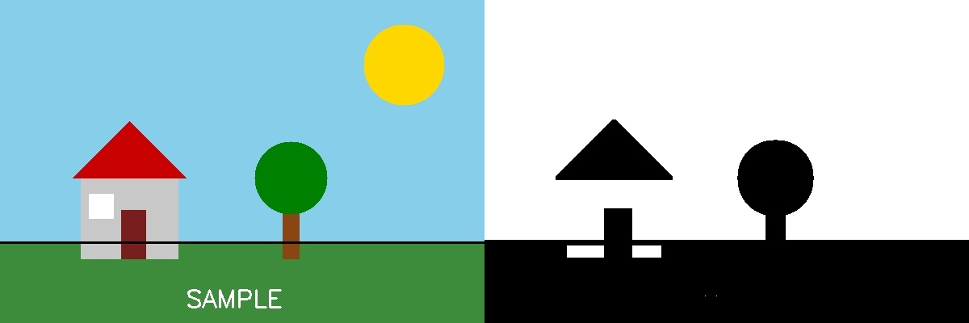
Fig. 29 — Output of Experiment 29: Morphological Operations using OpenCV — Erosion Technique.
RESULT
Apply the morphological Erosion operation on a binary image to shrink white foreground regions and remove small noise — completed successfully, as demonstrated in the output shown above.

